Cisco management devices, Console Telnet, SSH

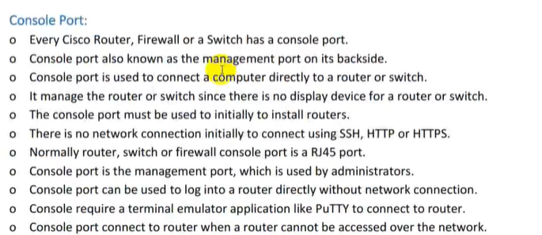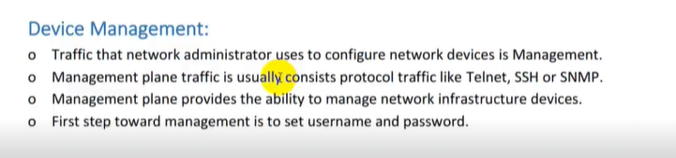

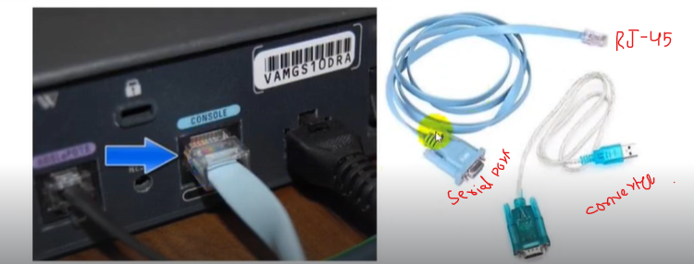

* This will allow us to work virtually on console of switch for practice.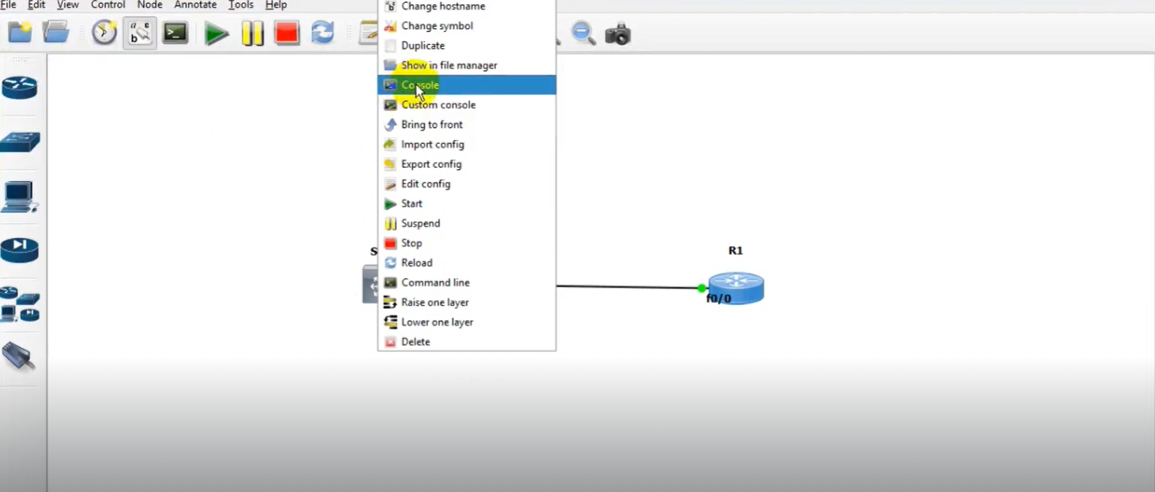

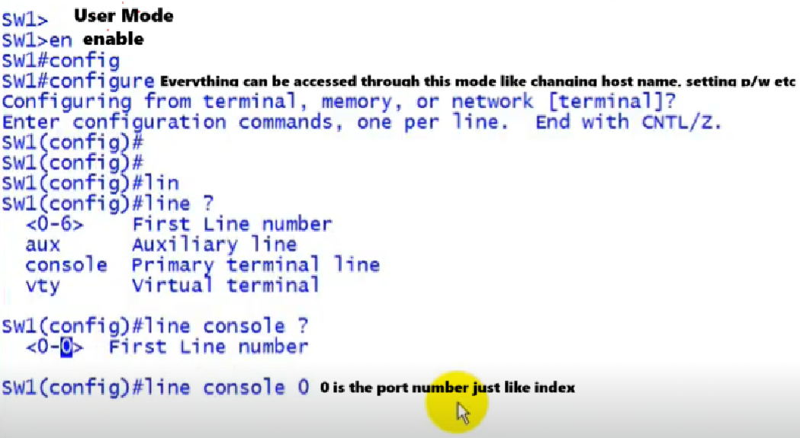

* After just setting p/w then setting username and p/w to secure console.

**Setting up Username And P/W**

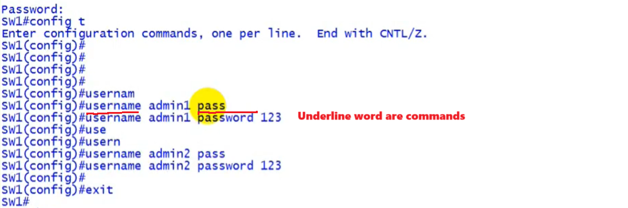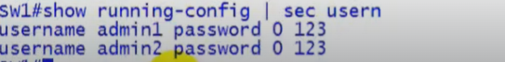

* Now these are in local data base so in configuration mode it must be specified **login local**.

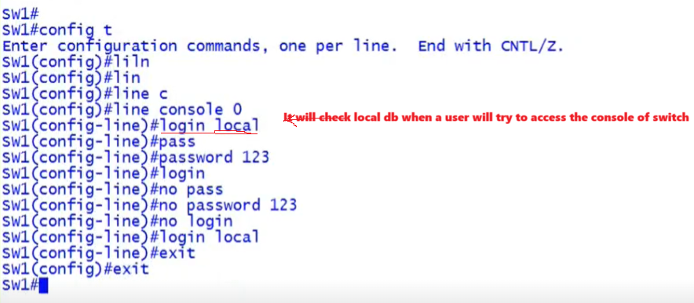

**Log in User Detail:**

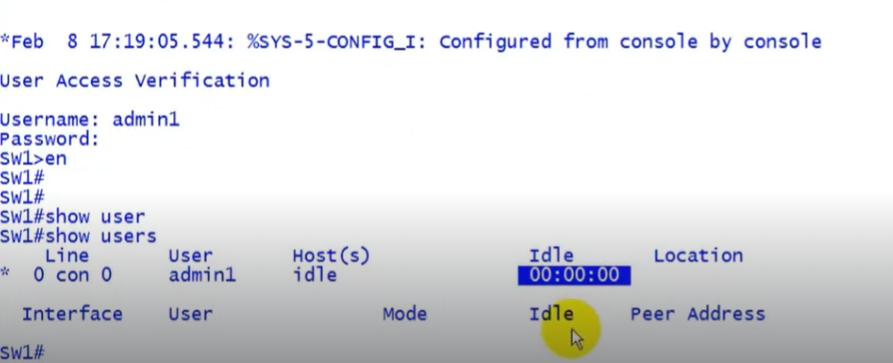

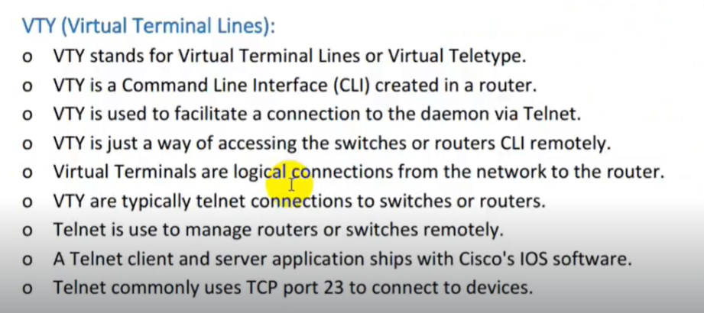

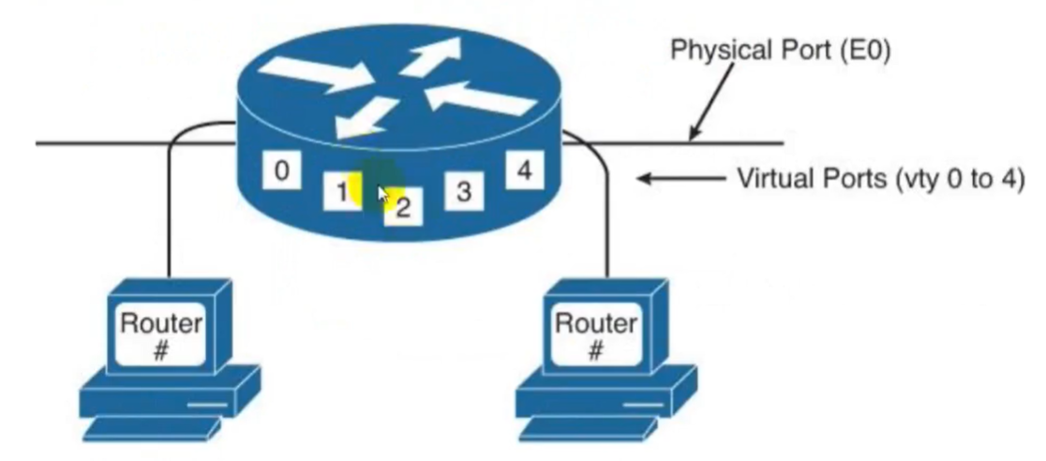

Assigning IP to Router For Telnet(Teletype Network)

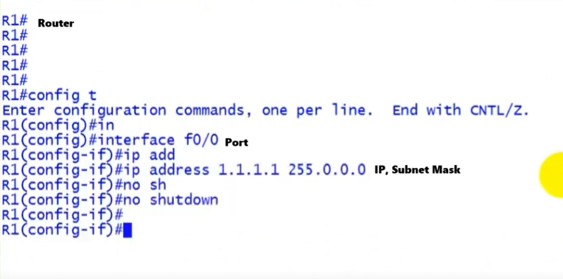

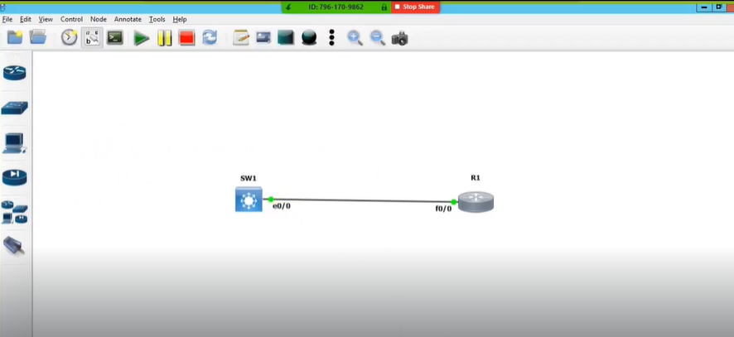

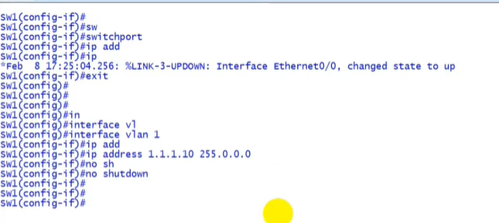  
**Assiging IP to Switch(Layer 2[no switch])**

* **SVI (Switch virtual Interface)** allows to assign IP in Layer 2 Switch for Telnet

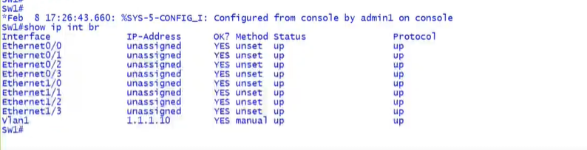**Show IP For Telnet:**

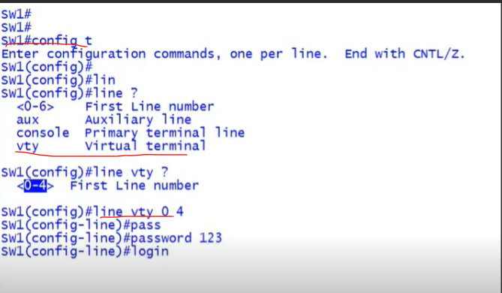

**TELNET:**

* It allows us to remotely control switch means the router or any device connected to switch using the terminal of that device we can configure Switch.
* In this picture we used router terminal to access switch Router is also connected to switch.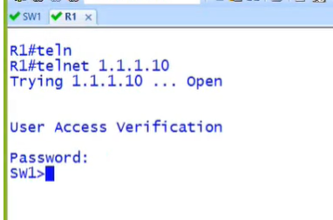

**Check Accessed User of Switch:** 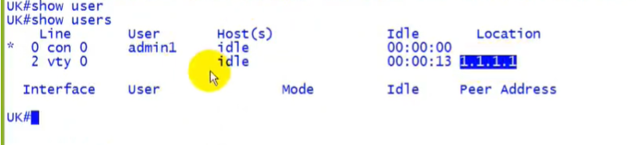

**Set Username & P/W for TELNET:**

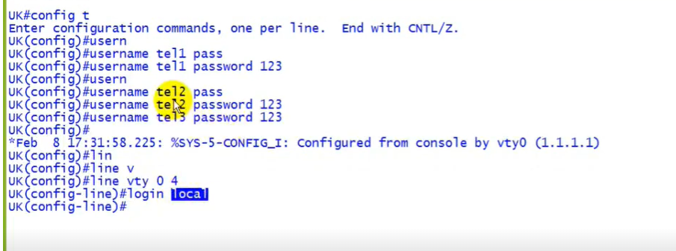

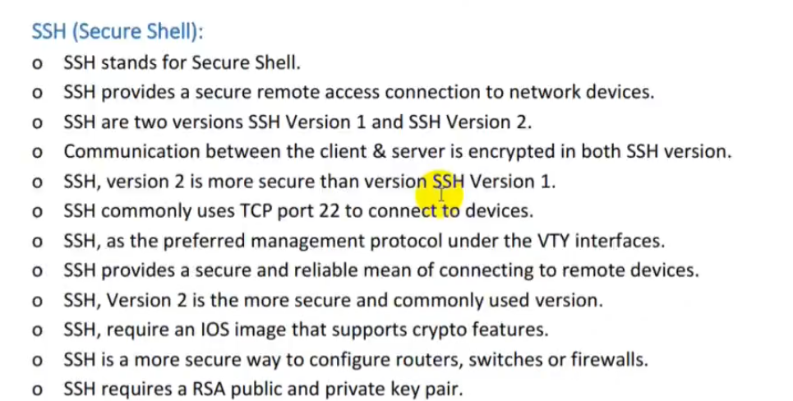

* Router & Switch Name should be different like sw (no). additinaly domain is required to generate key.